Hammer Them Strategy

Introduction

In this video, I'm going to break down the "Hammer Them" strategy, explaining how to effectively hammer prospects with emails and content to increase your show rates and close rates by pre-selling them before they even get on a sales call.

The entire goal of the Hammer Them strategy is to turn your salespeople into cashiers. This means that by the time a prospect gets on a sales call, they are no longer there for education. They've already had their questions answered, their objections handled, and their expectations set. The sales call becomes a simple logistical step to collect payment.

When a lead has been properly "hammered," the sales call is shorter, and the conversation shifts from "Why should I buy this?" to "How do I buy this?"

Full credit to Jeremy Haynes who this strategy originated from - this SOP is me expanding upon his strategy and making it relevant for marketing agencies.

What Is The Hammer Them?
The Hammer Them strategy is a high-frequency content and email blitz that you deploy in the 72-hour window between when someone books to when the call is scheduled. This is when their interest is at its peak, and you need to leverage recency bias to stay top-of-mind and indoctrinate them into your way of thinking.

The way it works is the minute a lead books a call, between then and the call which is typically anywhere from 24-72 hours, they immediately get a series of 10-20 pieces of content (both short and long form) and up to 6 emails a day blasting their feed and inbox. The sole purpose of this sequence is to pre-educate leads on the most common:
- Questions
- Objections
- Expectations

Most leads have that could cause them to come on the sales call uneducated or prevent them from buying. By doing so we increase the probability of our sales calls showing up and closing with less questions, less objections, and we condense the sales cycle timeline to be quicker than usual.

This strategy works hand in hand with the objection prevention videos we built out in the most recent Thank You Page Optimisation video (and puts it on steroids.)

[VISUAL BREAKDOWN]

Isn’t That Over The Top?

Now, I know what you're thinking: "15-20 pieces of content and 6 emails a day? Isn't that a guaranteed way to piss people off?"

This high frequency only works if the content is valuable and relevant. You're not spamming them with "buy now" messages. You are proactively answering every question they have in their head, making them feel understood and nurturing them before the call.

Why Does It Work?
The Hammer Them strategy is incredibly effective at boosting show rates and sales conversions due to several key psychological principles and mechanisms at play.

Reason 1: Familiarity Bias
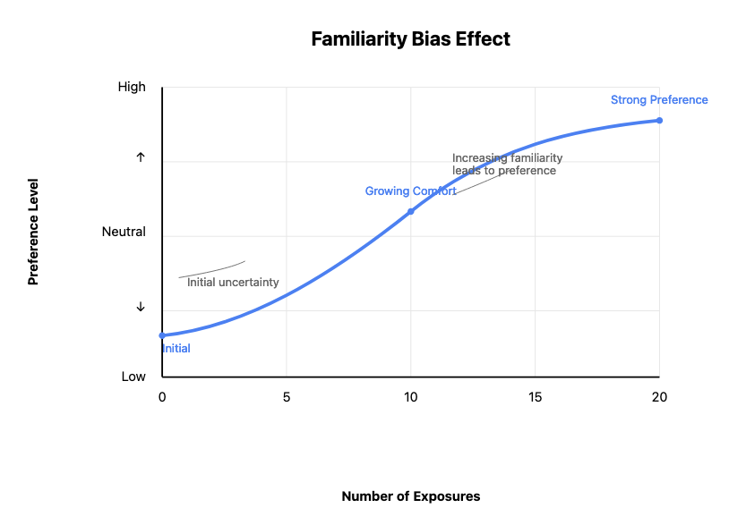
One of the core reasons this approach works so well is due to the familiarity bias. As humans, we have a natural tendency to prefer and trust things that we're exposed to repeatedly. By delivering a high volume of valuable, relevant content to your leads in the days leading up to the sales call, you're leveraging this bias to your advantage.

With each piece of content they consume, their familiarity with and trust in your agency grows stronger. Even if they don't consciously engage with every single piece, the mere fact that they're seeing your name, your face, and your message over and over again is subconsciously building trust and rapport before the call.

Reason 2: Exposure Effect
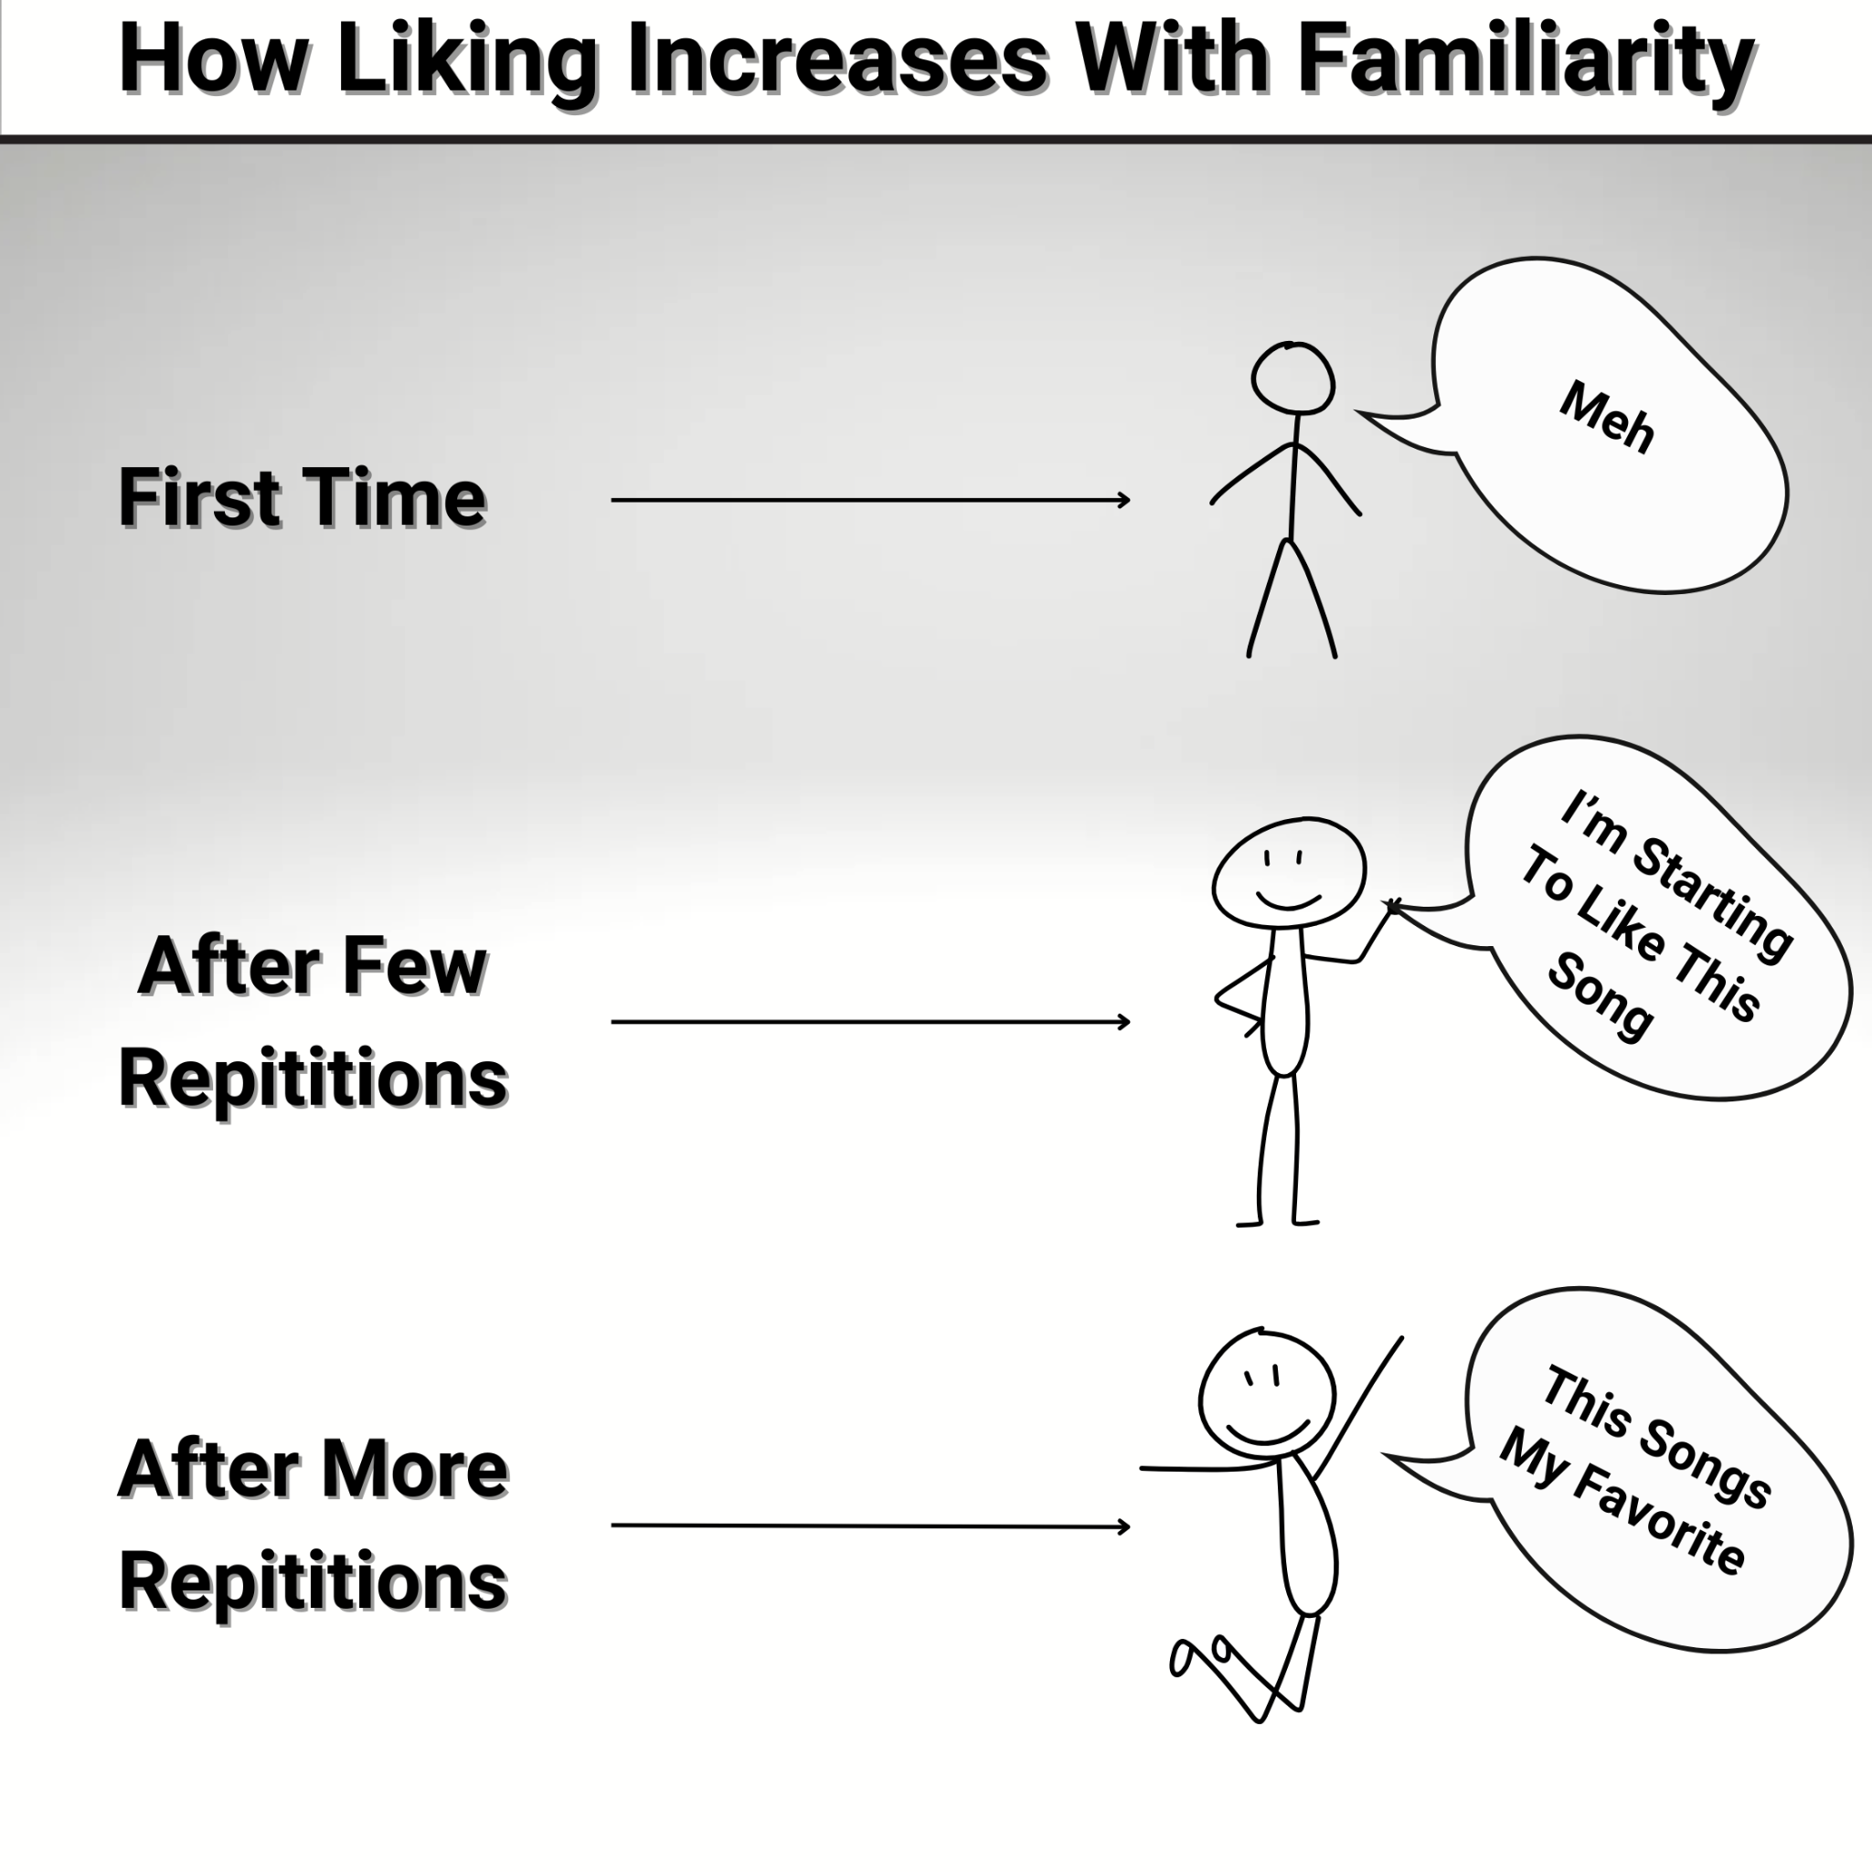
Closely related to the familiarity bias is the exposure effect. This states that people tend to develop a preference and trust for things simply because they are familiar with them. In other words, the more we're exposed to something, the more we tend to like it.

By bombarding your leads with a high frequency of content touchpoints in a short timeframe, you're capitalizing on this effect. Even if they don't click on or consciously consume every piece, the repetition of exposure is increasing their trust in your brand.

Reason 3: Selling The Next Step vs. The End Result
Another key factor that makes the Hammer Them approach so powerful is that you're not necessarily selling the end result or the product itself in your content. Instead, you're selling the next step - showing up to the sales call.

By focusing your content on building trust, providing value, and addressing objections and concerns related to taking that next step, you're removing barriers and increasing the likelihood that leads will show up to the call. You're making the act of attending the sales conversation feel like a natural, logical, and low-risk action.

This is a much more effective approach than trying to sell them on the entire offer or end result upfront. You're meeting them where they are in their journey and guiding them towards the desired action one step at a time.

Reason 4: Objection Handling and Question Answering
A significant portion of your Hammer Them content should be dedicated to proactively addressing the most common questions, concerns, and objections that your leads typically have. By doing this before the sales call even takes place, you're preempting potential roadblocks and smoothing the path to conversion.

When you provide clear, thorough, and persuasive answers to their key questions and objections upfront, leads come into the sales conversation feeling more informed, more confident, and more ready to engage. They're less likely to bring up those sticking points on the call, because you've already handled them in your content.

This not only increases show rates by removing doubts and building trust, but also makes the sales conversation itself more efficient and effective. Instead of getting bogged down in overcoming objections, you can focus on deepening the relationship and guiding them towards a buying decision. This is ascending them up the levels of interest (covered in the last video)
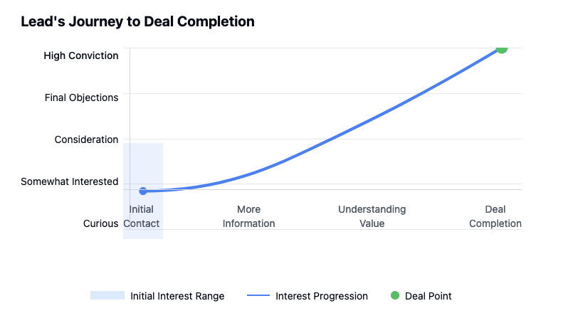

Content Buckets
We break the content of the hammer them content & emails into 3 core buckets:
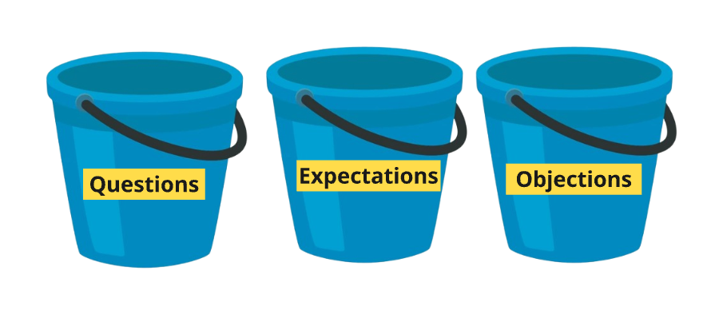
- Questions: Address the most critical, foundational questions about your offer.
  - 2nd Layer Questions: Answer the follow-up questions that naturally arise from your first answers.
- Objections: Confront the lingering doubts around price, time, and skepticism head-on.
- Expectations: Paint a clear, realistic picture of the journey and the results.

To first understand what topics to cover and what buckets to fit them under, get all your sales call transcripts into a google doc > download as a TXT file > throw them into ChatGPT and ask the following question: “Give me in order from highest to lowest frequency, the most common questions, objections, and expectations for me to make mini 1-2 minute breakout videos to send to prospects before the call to make sure they come on the call educated based on the sales call transcripts that my team has taken with prospects below. When giving me the questions to make videos around, give me detailed bullet points on WHAT to cover and quotes from people bringing it up on sales calls with exactly what they say” Make sure to segment your answers under the bucket of “objection” “question” or “expectation” and organize them accordingly

You should be left with an answer like this: Objection Question & Expectation Buckets

Then we create this content in both written and video format. My process for doing so is to always start with the email version, then translate that into a short form piece of content. Then with the long form content, our goal is to weave in these topics throughout the video while providing a shit ton of value.

Now lets go into breaking down how to create all 3 content types: Short form, long form, and emails.
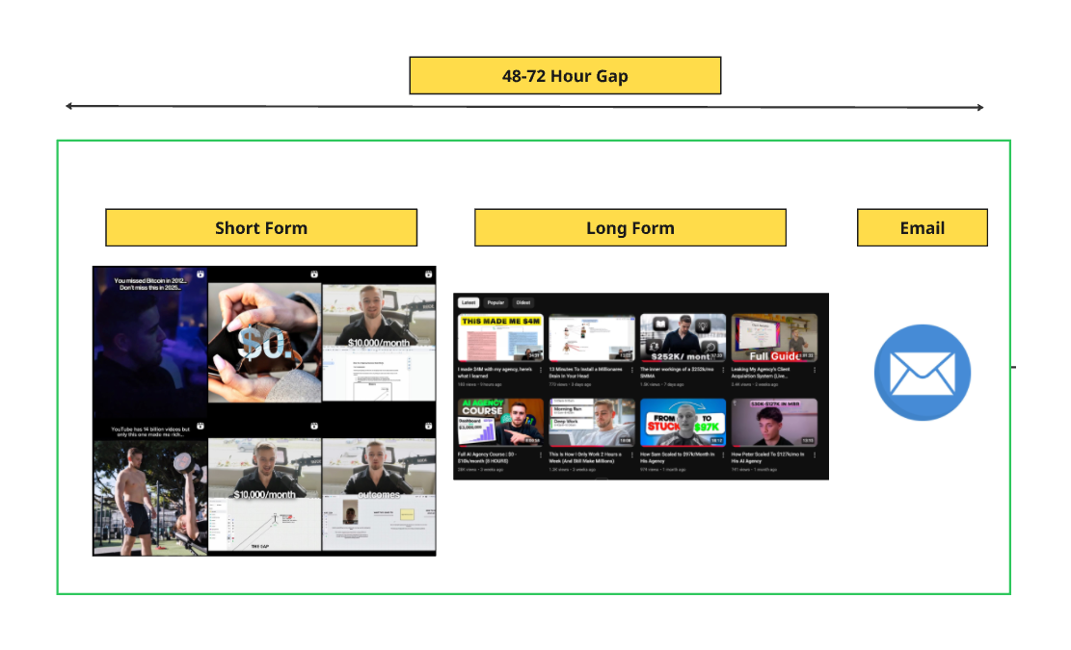

Emails
You can find the template to the hammer them campaign workflow inside of the B2B Snapshot called “hammer them” as shown below:
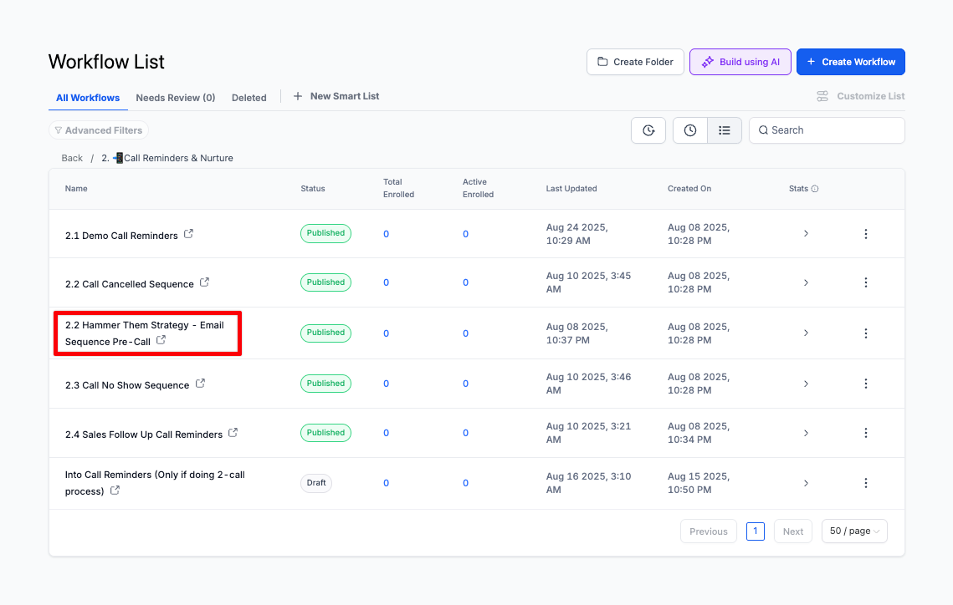
The emails are the backbone of this entire operation. They are the most direct and consistent line of communication you have with a prospect in that 72-hour window. Their job is not just to link to videos; their job is to deliver standalone value that answers questions, handles objections, and sets expectations directly in their inbox.

Ideation & Scripting

- Go into your AI tool of choice (I use Poppy.ai for this)
  - Use the Email AI Agent Template to help you write these out
    - If you don't use poppy you can use our internal Email AI Agent
- Feed it all your company identity docs:
  - Market research, sales scripts, VSL transcript…
  - Most common objections, questions, & expectations from earlier
  - Example emails you’ve written or content you’ve made so it can embody your language style
- Feed it this exact SOP so it understands the strategy.
  - This SOP
  - Hammer Them Email Sequence Template
    - Make sure to give the AI context on each resource and how you want it to use
- Input the following prompt once done:
  - Hammer Them Emails - Prompt

The AI will get you 70% of the way there, your job is to then refine it and put it into your GHL workflow (also lean on the slack to get feedback on your hammer-them emails.)

Also feel free to model my hammer them sequence for reference and even feed it to the AI tool for assistance: 18 Emails - Hammer Them License & Scale Pinpoint Scaling - 18 Email Hammer Them Sequence

There are also agency-specific examples within the snapshot you can model too.

Copywriting Formula

Every email should follow this 3-step formula:
- Acknowledge the Unspoken Question: Start with a subject line and first sentence that hits on a question or objection you know is in their head.
- Provide a Concise, Written Answer: Give them the core of the answer in the email itself. This is the standalone value.
- Offer the Video as a "Deep Dive": Frame the video as an optional resource for those who want more detail.
  - This can be an objection prevention video, or a long form YT video you’ve created expanding on the topic in the video

Email Example

Below is a breakdown of an example email we send a few minutes after someone books immediately crushing the biggest objection that would prevent them from showing:

SL: Is This Just Another "Facebook Ad" Lead Gen Service?

Hey {{contact.first_name}},

Let’s address what you’re probably thinking right now:

"Is this just another marketing agency that's going to take my money and send me a list of sh*tty, unqualified leads?"

Look, I get it.

We hear horror stories ALL THE TIME from Medspa owners about the agencies they’ve been burned by.

You know the drill:
- Promised appointments that never show up.
- "Qualified" leads who come into your office thinking one treatment will make them look 50-years younger
- Insane guarantees with contingencies so ridiculous you'd have a better chance of getting struck by lightning than getting your money back.

It’s why 99% of Medspa owners are skeptical about marketing agencies. And honestly? They SHOULD be.

Because the sad truth is most of them are garbage.

But here's where we are a bit different:

- We don't sell leads. We deliver financially qualified patients.
- Our US-based patient concierge team calls and vets every single person to make sure they have the money to spend before they ever touch your calendar.
- We do the grunt work of filtering out the good to the bad - so your team doesn't have to.

That's why our clients, like Dr. Oana, generated $17k in new cash patients in just 9 days. We have a flawless TrustPilot page because we actually deliver. (Check here for proof)

I'm not asking you to believe me yet.

But I am asking you to keep an open mind until our call.

Looking forward to showing you how we're different.

Talk soon,
{{user.first_name}} | CEO & Founder at {{custom_values.agency_name}}

Short Form
The short-form content is everything you cover in your emails, but in video format. Its job is to build the familiarity bias - you want your face to be everywhere, so by the time they get on the call, they feel like they already know you & your agency. These are quick, 30-90 second videos designed to hammer home a single idea, answer one question, or crush one objection.

Ideation Process
- Use the Same Intel: Your content topics come from the exact same AI output you used for the emails.
- One Idea, One Video: Take each question, objection, and expectation and turn it into a short, punchy video.

Framework & Script

Framework for Short-Form Video Script:
- Opening Hook (3-5 seconds): Grab attention immediately by calling out the pain point or objection.
- Pain Point (7-10 seconds): Empathize with their frustration and show you understand their experience.
- Reframe (10-15 seconds): Shift their perspective by explaining why their assumption might be wrong or incomplete.
- Solution (10-15 seconds): Position your unique solution as the answer to their problem.
- Closing Statement (5 seconds): End with a clear, confident statement that builds anticipation for the call and wraps up the video.

Topic: “Facebook ads don’t work I’ve tried them before and I got shitty leads” - most common objection (The same as the email we broke down earlier)

[Opening Hook - 3 Seconds]
“Facebook ad agencies are a scam, right?”

[Pain Point - 7 Seconds]
We hear horror stories all the time from our Medspa partners who have tried ads in the past, or maybe even worked with an agency or two and all it resulted in was:
- "Qualified" leads who come into your office thinking one treatment will make them look 50-years younger
- No shows
- The complete OPPOSITE of what they were expecting

[Reframe - 10 Seconds]

And when this happens they tend to think that the ads themselves are the problem, when that may not be the case…

If that was the case, the biggest Medspas in the WORLD wouldn’t be spending millions of dollars every year on Facebook ads…

You see there’s 4 parts of driving any successful online marketing campaign
- Getting leads
- Getting those leads to book
- Getting them to show
- Getting them to close

And usually the problem isn't with the ads itself, it's the other pieces of the puzzle most people simply don't know are so much more important…

[Solution - 15 Seconds]

That's why for our partners, we have a U.S.-based concierge team that calls every lead, vets them for financial qualifications, and makes sure they’re ready to buy before they ever hit your calendar. As a result Dr. Oana, generated $17k in new cash patients in just 9 days, and this is a pretty common result…”

[Closing Statement - 5 Seconds]

Next time you assume that ads don't work - before you decide it's the platform's problem. Make sure that you have these problems solved first.

Why This Works:
- The hook starts with the “splinter in their mind” after booking the call with you
- Breaks the belief of “ads not working” by educating them on the 4 pillars to running a campaign they probably didn’t know about
- We weaved in credibility and social proof to back up our claim
- Hammered the “what makes you different” objection by mentioning our US-based sales team

Example Content
- Expectations and questions
  - https://www.tiktok.com/@thejunglebadger/video/7430523110488542496
  - https://www.tiktok.com/@iamphilswift/video/7414163905158729003?q=flex%20seal&t=1731607319324
  - https://www.tiktok.com/@pretzelsinparadise/video/7256411887766818094
  - https://www.tiktok.com/@amalfijets/video/7422001665353583903
  - https://www.tiktok.com/@theultimatehumanofficial/video/7278114417672277281
- Questions
  - https://www.tiktok.com/@scrubdaddy/video/7179695615121820974
  - https://www.tiktok.com/@omarswheels/video/7250973870868401454
- All Buckets
  - https://www.tiktok.com/@getflexseal/video/7135120415298555182?q=flex%20seal&t=1731607319324
  - https://www.tiktok.com/@getflexseal/video/7398230426797477163?q=flex%20seal&t=1731607319324
- My Examples
  - Pinpoint Scaling
    - Hammer Them (PPS)
  - License & Scale
    - https://www.instagram.com/p/DN8MZmZEzkp/ - “courses are scams” objection + limiting belief
    - https://www.instagram.com/p/DN5rnOLk841/ - expectations
    - https://www.instagram.com/p/DNnl8mATnp9/ - framing them to wanna buy my thing
    - https://www.instagram.com/p/DMu_2Mlz_rS/ - framing
    - https://www.instagram.com/p/DMBQHcxAxcm/ - questions
    - https://www.instagram.com/p/DLMrVbJNovQ/ - framing
    - https://www.instagram.com/p/DLFPdaht-9e/ - framing / breaking beliefs

For recording content like this all you need is a somewhat decent iphone, here’s my process for doing so: VIDEO SOP

For more context on filming & editing content, watch Filming & Editing

Finally, make sure you make a minimum of 10-20 pieces of short form content to start. We’ll be diving into the technical campaign setup shortly.

Long Form
Long-form content is your authority play. It's where you build deep trust and kill skepticism. This content isn’t necessarily just created to answer/overcome questions, objections, and set expectations, however you should be weaving those things throughout your long form content.

Ultimate conviction in your & your agency is created through long form content.

For long form, you need to keep a few things in mind:
- Value Density: Every minute of your long form has to deliver an immense amount of value. If you’re making them sit through 10, 20, or even 60 minutes of content, every second better be worth their time. Modern buyers are impatient, so you need to pack it with insights, proof, and actionable takeaways.
- Storytelling: Long form gives you the space to tell stories that resonate. Case studies, client transformations, or even your own journey - these are the things that make people trust you.
  - This is the perfect point to weave in points from your 3 content buckets
- Proof and Expertise: Long form is where you flex. Show them you know your stuff. Dive into the nitty-gritty details of your process, share data, and demonstrate why you’re the best at what you do.
  - The beauty of long form is that it’s not for everyone - but the people who consume it are your most serious buyers. They’re the ones who binge your content, show up to calls ready to buy, and often close at higher ticket prices.

Think about what sold you on this program… It was probably my long form YouTube content. It made you so convicted in me “being your guy” and that I can help solve your problems, most of you either bought via text or came on calls with literally zero objections.

Example Content
- I made $4M with my agency, here’s what I learned
  - Perfect example of me intentionally making content to break beliefs. One of the key points I hammer home here is how impactful it was to invest in coaching to help me grow and addressing the beliefs that stopped me from doing so that other people are experiencing
- The inner workings of a $252k/mo SMMA - Value density
- Secret Recording from a '6-7 figure-Only' Agency Mastermind, (Please Do Not Share) - Authority & credibility
- How I built a $3m/yr business at 19 (my story) - Storytelling, proof, trust building
- I've Onboarded 400+ Clients in my SMMA, here's exactly how I do it - Value density
- Leaking My Agency's Client Acquisition System (Live Mastermind) - Value density
- How Sam Scaled to $97k/Month In His Agency - social proof, questions, objections, expectations (all buckets)

Campaign Setup
Now you understand how to create the short form and long form content, the next step in the process is setting up your campaign to intentionally retarget your leads with this content.

All campaigns including the long form content will be run natively inside of Meta, if you’re inputting long form content right away, you just simply download the video using a youtube video downloader and upload it into the ads manager.

- Our goal with both campaigns is to achieve a 15-20 frequency, we do not look at any metrics besides this due to the goal not being to get clicks, bookings, or anything of the sort.
  - Our goal is to indoctrinate them with our content. You can typically achieve this frequency on a $10-$30 daily spend
- Within our targeting we only include people who have booked a call in the last 3-7 days, if your audience size is less than 100 people, then you should also include people who have clicked on your landing page but didn’t opt-in
- Then we also exclude people who watch a certain duration of each video from seeing that video again to prevent them from seeing the same shit 50 times over

Here’s the setup SOP on how to do this with a video breakdown: Hammer Them Technical Setup

FAQ
Below is a breakdown of some of the questions I had when building this out, that you’ll probably have too.

- If my show rate and close rate is already really good, should I set this up or is it just a distraction to scaling what's working?
  - If your show rate is already 80%+ and your close rate is 30%+, then you're right, this might be a distraction for now. Your biggest constraint is likely at the top of the funnel - you just need more lead flow.
  - However, as you scale your ad spend and your lead volume increases, you will inevitably see a drop in lead quality and show rates. That is the trigger point to implement the Hammer Them strategy.
  - This strategy can still help you scale faster and more efficiently, but it might not be the most immediate thing you implement
- This seems like a big setup, what's the minimum viable setup for someone with no content?
  - Start with the emails right out the gate almost anyone can do these regardless of how many videos you already have - then overtime you can make them better by weaving in videos, and more visuals of social proof etc etc…
  - I’d recommend blocking out a day in your calendar and just hammering out 5-10 short form videos and a handful of long form pieces of content based around the content buckets
- What if I have leads who book for tomorrow or a week out? Won't the emails they get be unequal or imbalanced?
  - I wouldn't worry about this too much initially, however further down the line you may wanna consider segmenting the lead booking windows to send out different frequencies on the emails. The content doesn't matter as much, but what does matter is the email frequency and spacing that out in accordance with how far out they book.
    - One thing you should absolutely do is put your non negotiable, most important emails into your call reminder sequence INSTEAD of the hammer them workflow, which guarantees they receive those emails. We do this with the objection email, social proof assets, and the “be the person who shows up” email.
  - At scale the fix is segmenting leads based on call times. Add an 'if/else' step in your GHL workflow. If a lead books within 72 hours, they get the full, high-frequency 'Sprint' hammer. But if they book a week out, they get the 'Marathon': you still hit them hard for the first 48 hours to lock in their interest, then you switch to a lower-frequency 'simmer' phase with your best long-form content to keep them warm, and then you re-hammer them with the full-intensity blitz in the final 48 hours before the call. This ensures every single lead, no matter when they book, shows up to the call hot.
- How do I know how many emails I should be sending in my hammer-them sequence and what if 18 is too many?
  - Remember that people don’t hate emails - they hate irrelevant emails. As long as your emails are valuable, engaging, and aligned with their pain points, you’re good.
  - My rule of thumb for adjusting this is at the points in the sequence where your open rates start to diminish, for ex: you see on email 4 each day your open rates go from 50%+ to 20%, then first test new subject lines, but if the issue still persists the you know that email is the “dropoff” point.
- My agency targets prospects who are barely on YouTube or social media in general. They don't watch a lot of content. Will this strategy still work?
  - For Blue-Collar Niches (e.g., Roofers, Plumbers): They might not watch a 45-minute podcast, but they will absolutely watch a 60-second video of you showing them a "before and after" of a client's lead flow, or a quick video breaking down how your guarantee means they can't possibly lose. The content just needs to be more direct, visual, and less theoretical.
  - For Highly Sophisticated Niches (e.g., Lawyers, Financial Advisors): They are even more likely to consume your content if it's high-value. They do their due diligence. They will read your emails and watch your long-form content if it proves you're an expert and not an idiot. For them, the content needs to be data-heavy, logical, and full of proof.
    - The strategy doesn't change; you just adapt the type of the content to match your market.
- How do I actually track the ROI of this strategy if I don't have any metrics to look at on the campaign in the ads manager, how can I prove it's working?
  - The most important metrics are the show rate & close rate. Compare pre-Hammer Them metrics to post-Hammer Them metrics. If you’re not seeing a lift, it’s either a content issue or a frequency problem.
  - Sales Team Intel: Ask your sales team, "Are the leads coming to calls more educated and less skeptical?" If the answer is yes, it's working.
  - Sales Cycle Length: Track the average time from "booked call" to "closed deal." A successful Hammer Them strategy will shorten this cycle because leads are coming in pre-sold.
- What's a realistic daily ad budget for the retargeting campaigns?
  - This is the cheapest, highest-ROI ad spend you will ever have. We're targeting a warm audience of people who have already booked a call.
  - A realistic budget to start is $10-$25 per day. For a smaller audience (under 300 people), that's often enough to hit that frequency target of 15-20+.
- How many pieces of content do I actually need to create?
  - You need 30-50 short-form videos and 20-30 long-form pieces for a fully optimized Hammer Them strategy. Anything less than 30 short-form pieces will degrade performance. If you’re just starting, focus on the most common objections, questions, and expectations first, then build out from there.
- How do I ensure my content doesn’t feel repetitive?
  - You ensure it doesn't feel repetitive by attacking the same core idea from multiple different angles
    - For ex:, let's say your core idea is "Our guarantee means you can't lose."
      - Content Piece 1 (Objection Angle): A video titled "What Happens If This Doesn't Work?"
      - Content Piece 2 (Story Angle): A video telling the story of a skeptical client who was won over by the guarantee.
      - Content Piece 3 (Logic Angle): A short video breaking down the math of why the guarantee makes it a no-brainer decision.
    - It's the same core message, but delivered in three completely different ways.
- How do I handle exclusions in the ad setup?
  - You create a separate ad set for each piece of content. Then, you create a custom audience of people who have watched 3 seconds of that specific video and exclude that audience from that specific ad set. This is the most precise way to ensure content rotation, but it's an operational nightmare for beginners. Start with the simple CBO setup.
    - For long form I’d recommend this being 10 seconds due to the video naturally being longer

